Experiment No:- 01

Aim:-
To understand DevOPs; Principles, Practices, DevOps engineer role and responsibility

Theory:
What is DevOps?
DevOps is a blend of practices, and tools, that help organizations grow in terms of delivering applications and services efficiently. It helps to improve the products at a faster speed than using traditional software development and infrastructure management processes.

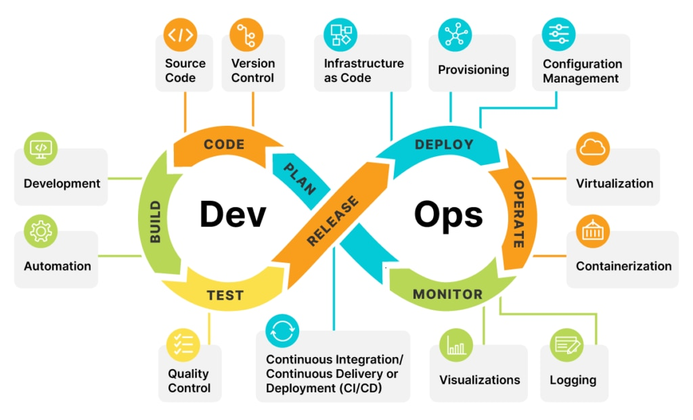

Principles of DevOps:
- Automation of the software development lifecycle: This process includes automating testing, builds, releases, and many other manual tasks that can reduce the software delivery process
- Collaboration and communication: Communication and collaboration is very much required in DevOps as it helps you to work on products effectively with fewer bugs.
- Continuous improvement and minimization of waste: Due to regular updates taken from the team, and watching performance metrics, to work on software delivery.
- Hyper-focus on user needs with short feedback loops: Through automation, improved communication and collaboration, and continuous improvement, DevOps teams can focus on what real users really want, and how to deliver it to them.

What is a DevOps engineer?

A DevOps engineer is an IT generalist who should have a wide-ranging knowledge of both development and operations, including coding, infrastructure management, system administration, and DevOps toolchains. DevOps engineers should also possess interpersonal skills since they work across company silos to create a more collaborative environment.

Roles and responsibilities:

The role of a DevOps engineer will vary from one organization to another, but invariably entails some combination of release engineering, infrastructure provisioning and management, system administration, security, and DevOps advocacy. Release engineering includes the work required to build and deploy application code. The exact tools and processes vary widely depending on many variables, such as what language the code is written in, how much of the pipeline has been automated, and whether the production infrastructure is on-premise or in the cloud. Release engineering might entail selecting, provisioning, and maintaining CI/CD tooling or writing and maintaining bespoke build/deploy scripts.Infrastructure provisioning and system administration include deploying and maintaining the servers, storage, and networking resources required to host applications. For organizations with on-premise resources this might include managing physical servers, storage devices, switches, and virtualization software in a data center. For a hybrid or entirely cloud-based organization this will usually include provisioning and managing virtual instances of the same components.

Conclusion:-
Hence we study DevOps and there Practices, DevOps engineer role and responsibility

